Hannah Ashna Jacob

(N0865554)

Serious Games report

Contents

Literature Review 3

User Analysis 3

Task Analysis 4

Environment Analysis 4

Design Matrix 5

Design Document 7

Game Overview 7

Core Objectives 7

Gameplay Theme 7

Game Structure 8

Distinctive Features 8

Important Assets 9

Reward and Scoring Mechanism 10

Control Mechanism 11

Interface Mechanism 11

Storyboard 12

References 13

# Literature Review

Games for education is not a novel concept. The application of educational serious games can be seen within a variety of different sectors for example in medicine (Tsopra et al. 2020; Hannig et al. 2012), aviation (Chittaro, Buttussi 2015), and even linguistics (Alyaz et al. 2017). Sustainability is no exception to this as can be seen in games like Imagine Earth (Serious Brothers 2022) and Crabby’s Reef (SeriousGeoGames Lab 2022).

This raises the question of what serious games can achieve that other more traditional methods of education cannot. Research into the use of gaming in education found that it can make “learning easier”, “student-centred” and “engaging” and thus, more effectively deliver the subject matter (Rossano et al. 2017, p.49). Serious games have also been noted to facilitate knowledge and skill acquisition in learners (Papastergiou 2009). Moreover, it’s been found that the gaming dimension can also assist learners in developing their “cognitive abilities” and help some “step beyond the boundaries of conventional learning” (Ullah et al. 2022, p.202).

From the perspective of biodiversity, conservation, and climate change there are a few different ways in which a serious game can contribute to the cause. The study by Sandbrook et al. identifies the primary three mechanisms by which games could aid in biodiversity conservation efforts: education and behaviour change, fundraising, and research promotion (Sandbrook et al. 2014).

## User Analysis

Through an understanding of the client’s (Nottingham Trent University 2022) requirements, this project’s game leans towards the education and behaviour change mechanism. The client’s needs denote the need for a game that can be used to facilitate discussion in higher education level classrooms and that would equip players with a more detailed understanding of the chosen United Nations Sustainable Development Goals (UN SDGs) (United Nations Department of Economic and Social Affairs 2022). Thus, the project’s target audience would be university students. The goal of the game is to educate players on the relationship between biodiversity and climate change in ‘winterbourne’ chalk streams (Stubbington et al. 2017; Hampshire & Isle of Wight Wildlife Trust 2021; The Conversation 2022) and as a result, potentially inspire a desire for climate action in this area.

A common criticism surrounding the conversation about sustainability and conservation is that it can sometimes be “too boring” or “too vague” (Down 2006; Dernbach, Cheever 2015). Hence the need for a game that retains the user’s interest while subtly educating the player on key sustainability concepts. The use of gamification and allegory might be the answer to these criticisms. An example of this can be seen in a study on the game entitled ‘The Island’ wherein university students had to manage their resources as they governed a defined territory (Peña Miguel et al. 2020). Within the game, the players had to actively make decisions that would have either positive or negative ecological impacts on their surroundings. The study found that the game helped strengthen students’ understanding of sustainability and that the key factor behind this success was the integration of the UNESCO Education for Sustainable Development competencies. A few more examples include games such as Imagine Earth (Serious Brothers 2022) and SeAdventure(Rossano et al. 2017)**.**

In addition to designing a game that is both interesting and educational, the game should also consider the experience level of its players alongside other accessibility factors. The client’s requirements outline the need for a game that can be accessed easily and is suitable for a wide variety of players. A player’s previous gaming experience is a factor in this; not everyone can be assumed to have experience with browser-based games and thus, this emphasises the need for an interactive tutorial screen (Game Accessibility Guidelines 2022). This is to ensure that players do not experience any barriers to understanding how the game’s fundamental mechanics work. This further ensures that the player can become immersed in the content of the game without having to need to break immersion to query how a certain mechanic works. Subsequently, other accessibility factors also play a role in this. One key factor would be the aesthetic choices made during the game’s design stage. For players that might be visually impaired, modifications made to ensure that the game is still accessible to them are crucial. This includes adhering to guidelines outlined in both the National Learning Network Guidelines (National Learning Network n.d.) and the Web Content Accessibility Guidelines (Web Content Accessibility Guidelines (WCAG) 2022)

## Task Analysis

Based on this understanding of the impact serious games has on sustainability education, the next factor to consider is the relevant guidelines involved in ensuring that the game’s objectives and tasks are designed in a manner that best communicates and educates individuals on the relevant subject matter.

UNESCO’s guidelines on Education for Sustainable Development (Quality Assurance Agency for Higher Education, Advance HE 2021) are one such example. It outlines several different competencies that could be potentially covered and taught by a serious game. To ensure that the users come away from the game with a base understanding of the issues surrounding the battle between climate change and the chalk stream biodiversity, the game needs to ensure that it facilitates critical thinking, anticipatory and self-awareness competencies (Peña Miguel et al. 2020). By developing a sense of self-awareness within the game, the player will slowly begin to understand how their actions can impact the surrounding world. This understanding can then be converted to active climate action outside of the game.

To develop and shape these competencies in its players, the game needs to include relevant subject material. To achieve this, the game must utilise critical perspectives surrounding the impact of climate change on the chalk stream biodiversity. Moreover, the game should also include discussion surrounding the related Sustainable Development Goals (SDGs) (United Nations Department of Economic and Social Affairs 2022) so that players can link their understanding of the game’s content back to current efforts aimed at sustainability.

## Environment Analysis

Client requirements highlight the importance of ease of access and thus, developing a game that is playable via a web browser ensures that

# Design Matrix

|  |  |  |  |
| --- | --- | --- | --- |
| **Source** | **Observations** | **Requirement** | **Ideas** |
| User Analysis | | | |
| Client notes based on Green Academy’s briefing  Literature Review findings | Players are university students | The game should uniquely present information so that those who are either new to the material or quite knowledgeable about it can enjoy the gameplay experience | The game will incorporate a visual novel style of storytelling that involves the player in the narrative’s events |
| Players might not be experienced ‘gamers’ | The game must include a tutorial (Game Accessibility Guidelines 2022) | The game will include a brief trial level that walks the player through key mechanics |
| Players might be uninterested in a sustainability-centred game (Dernbach, Cheever 2015) | The game must convey information in a method that captures a player’s sense of intrigue and is memorable | The game is set in a high fantasy allegorical scenario to drive interest in the subject material |
| Task Analysis | | | |
| Client notes based on Green Academy’s briefing  Literature Review findings | Encourage critical discussion and exploration of learning | The game must help players facilitate one or more of the UNESCO ESD Competencies (Quality Assurance Agency for Higher Education, Advance HE 2021) | The game will develop a player’s self-awareness, critical thinking, and problem-solving competencies through its ‘questing’ mechanic |
| Promote a wider understanding of sustainability concerning existing climate change issues | The game should reference the UN Sustainable Development Goals (SDGs) (United Nations Department of Economic and Social Affairs 2022) | Player interaction with characters will include discussions on life below water, responsible consumption, and climate action SDGs |
| Designed with a clearly defined ending | The game should be designed for short-term development and include a definitive ending instead of being an open-ended simulation | The game will end once the player fails to complete all their quests within the allocated time limit. The game will also point out that the reduced time limit is a result of climate change’s influence on the biodiversity |
| Offers critical perspectives on the topic area | The game must involve a discussion on climate change’s influence on the biodiversity in chalk streams | The game’s questing mechanic will include tasks based on combating the influence of climate change within the chalk stream fantasy village. It will also include NPC’s (the wildlife) commentary on the negative impact climate change has on their lives |
| Environment Analysis | | | |
| Client notes based on Green Academy’s briefing  Literature Review findings | Limited time allocated for gameplay | The gameplay time should run for a maximum of 10 – 15 minutes | The gameplay is cyclical in nature, alternating between two distinct phases that get across the message within the first few rounds. Additional rounds are used to further emphasise the core learning objectives of the game. |
| The game will be played on a variety of devices | The game must be easily accessible | The game will be browser-based so that it can run on any device |
| Parallel Products | | | |
| Products that address a similar topic or are included within the sustainability and climate change area | Sustainability Games – it’s a quiz-based system that teaches players about the SDGs with a quantifiable outcome after each quiz round | The game must include a scoring system that allows users to compare and discuss their performance post-game | The game will include a timer to denote how fast quests were completed in each run of the game’s levels. In addition to this, it'll also include a display at the end that highlights how many levels a player survived. |
| Crabby’s Reef – Classic arcade-style game that explores the impact of ocean acidification on marine wildlife. |  |  |
|  |  |  |
|  |  |  |
| Design Guidelines | | | |
| Literature Review findings | Users may be colourblind |  |  |
|  |  |  |  |
|  |  |  |  |
|  |  |  |  |

# Design Document

## Game Overview

The Winterbourne Babysitter is a single-player web-browser-hosted game set in an allegorical fantasy village scene based on the winterbourne chalk streams. The village residents are made up of the whimsical biodiversity that can be found in such a place. Players enter the game as a tiny humanoid dragon, a Kobold, that’s been enlisted to help take care of the villager’s eggs during the drought season. However, when climate change begins to negatively impact the weather conditions, the player must begin to battle against the unpredictability of nature to ensure the community continues to thrive.

## Core Objectives

The core objective of Winterbourne Babysitter is that the player aids the community in surviving and thriving for as long as possible. While they progress through the game, the player will hone several different ESD competencies (Quality Assurance Agency for Higher Education, Advance HE 2021) as they gain a better understanding of the relevant SDGs (United Nations Department of Economic and Social Affairs 2022) and subject material so that they can participate in a classroom discussion upon the game’s completion.

To achieve this, the game is broken down into two distinct, alternating phases. Each contains its distinct game mechanic. The first is the questing mechanic that occurs in the ‘non-drought’ period of the game. Players will have the opportunity to either accept or decline quests provided to them by the village leader, Mr Trutta. These quests will influence how many relevant resources they’re able to gather during the non-drought phase of the game to then later be used during the drought phase. These quests also allow the player to involve other NPC members of the community. The more people they enlist the more resources they can gather in that period in addition to potentially triggering the game’s win condition. This feature of the game will encourage players to understand that there is power in local climate action. Moreover, it will subtly hone their self-awareness competency as they begin to see the impact they can have within the community at a local level and how this could translate into real-life actions.

The other mechanic is the resource management mechanic which occurs in the ‘drought’ phase. During the drought period of the game, players will be tasked with caring for the eggs within the village’s nursery. This nursery will contain an assortment of eggs with unique comfort thresholds based on their species. The goal of this section is to have the player manage and utilise their resources to ensure the highest number of eggs survive the unpredictable drought conditions. As players must be strategic with how they use their resources this feature will encourage them to develop their critical thinking competency.

## Gameplay Theme

The most prominent gameplay theme of the Winterbourne Babysitter can be seen through its use of visual novel-style elements to push forth the fantasy storyline. In addition to this, the game utilises themes surrounding urgency and the strength in numbers concept to further denote the ongoing concerns at a global scale of how climate change is rather quickly negatively impacting the biodiversity of chalk streams. By emphasising the importance of strength in numbers, players are introduced to the idea that by banding together at a local level, there is still an opportunity for them as individuals to rise to the call to action and positively impact their community.

## Game Structure

Winterbourne Babysitter is cyclical in nature. It moves between two distinct phases: drought and non-drought periods. This is in line with client requirements for a game with a clearly defined ending that’s able to present its message within 10-15 minutes of gameplay. The cyclical structure of the game allows the player to experience the ups and downs of local action in combating climate change.

The non-drought periods are an opportunity for the player to connect with the community and gather resources through a series of quests provided to them by the village leader, Mr Trutta. The quests will involve knitting blankets or making fans using environmentally friendly resources in reference to the responsible consumption and production SDG. To create more resources in the same period, players can speak to other NPC villagers to get a helping hand in building up their resources. All these quest actions come with a time cost; players must strategically decide how best to utilise their limited resource-gathering time before the next drought arrives.

The drought period will have the player stationed within the village nursery. This is where they’ll spend the entire duration caring for the village eggs. Each egg has a comfort threshold wherein they have specific temperatures that when exceeded could result in them being too hot or too cold. The player needs to use their resources to ensure the eggs remain at a comfortable temperature. Each species’ egg will have a different threshold and thus will react slightly differently to the ever-changing weather conditions. When an egg remains outside of its threshold for too long (i.e., 3 or more days) it will die. This is in reference to the life below water SDG wherein rising temperatures are a concern for certain aquatic species and in the case of chalk streams, the unpredictable temperatures are making it harder for the biodiversity to adapt quickly enough to ensure their survival.

The game increases in difficulty as time progresses, with each passing phase, the drought periods will become less predictable in when they occur, and they will also become more frequent and hotter. This is designed to represent the ongoing influence climate change has on existing real-world drought conditions, thus offering a critical perspective on how climate change is affecting chalk stream biodiversity. Thus, simulating the conditions within the game and further highlighting the impending importance of local action to combat the influence of climate change on the winterbourne village’s biodiversity.

## Distinctive Features

To successfully evoke a sense of concern and sadness in the player when they interact with the community, the game carefully places the responsibility for the community’s survival in the player's hands. Eggs will represent their species and in the case that no egg of a specific species survives the drought period it was in then the game will dynamically respond to this and cause the ‘extinction’ of the species within the community. Thus, the player will no longer see that species amongst the rest of the community members again.

However, to ensure that the player doesn’t come away from the game feeling defeated, the game provides them with the opportunity to rely on the community for support through the questing mechanic. As mentioned previously, by reaching out to community members for help, players can gather a greater number of resources during a non-drought period than they would have if they’d done it on their own. The more resources a player gathers before the drought period, the more likely they are to ensure the survival of all the eggs. This in turn will evoke a desire for action within the player outside of the game and ultimately further develop their self-awareness competency.

## Important Assets

As Winterbourne Babysitter will move between two distinct periods, it will also utilise two different locations where the player will be based in. This will be the nursery and the workshop. Both scenes will be designed using ‘DungeonDraft’ (Megasploot 2022), a fantasy map creation tool so that its aesthetics are in line with the rest of the game’s fantasy elements.

Within the visual novel-inspired user interface (UI) for conversations and quest decisions, the game will utilise a 2D simplistic rendering of its characters i.e., the player (see Fig. 1) and Mr Trutta (see Fig. 2). These will come with an additional set of design variations that will be used as part of the conversation animations to provide a bit more variation to the game scene. For the moveable player character within the nursery scene so that they may interact with the eggs, a pixel art sprite sheet will be designed in Photoshop to complement the other UI elements.

Figure - Carl the Kobold's Design

Figure - Mr. Trutta's Design

The other UI elements will be designed with the fantasy theme in mind so that all the different aesthetic choices fit together cohesively.

With regards to music, the game will employ the use of audio tracks such as ‘River Town’ and ‘Hidden Valley’ from ‘Tabletop Audio’ (Tabletop Audio 2022) to further build upon the fantasy village’s ambience so that the player is immediately transported and immersed into the allegorical fantasy world as soon as they hit play.

## Reward and Scoring Mechanism

During the non-drought phase of the game, the player needs to gather resources within the limited time available to them. In the early stages of the game, the non-drought phase will be much longer, roughly spanning 16 to 20 in-game days. This is to allow the player to have enough time to gather these resources on their own. As seen in the figure below, a player can make a single fan in 6 in-game days or a single blanket in 3 in-game days. After the first drought phase is completed, the player unlocks the ability to recruit other villagers to aid them in their mission. For every additional recruit a player gets, they can make an additional item during that time frame (i.e., 2 recruits and a player will be able to make 3 fans in 6 in-game days).

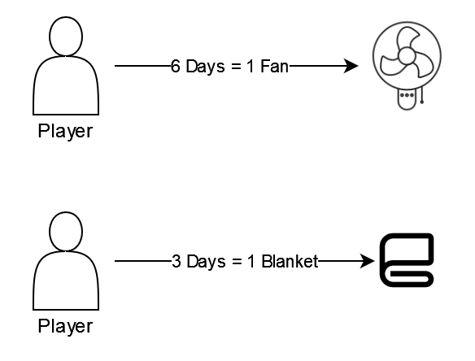

Figure - Diagram detailing the time cost for each resource

Recruiting helpers will not be a simple process, especially when a player has recently lost an egg during the drought period. Their persuasiveness will depend on how successful they’ve been in safeguarding eggs during the most recent drought. The probability of success will be calculated based on the ratio of how many eggs survived with the overall number of eggs present at the beginning of the drought.

In addition to the above, recruiting villagers can potentially unlock the game’s subtle win condition that’s designed to highlight the importance of the climate action SDG. Players will need to have recruited a total of 5 helpers over the course of the game to trigger the win condition wherein Mr Trutta will inform the player that the community’s efforts in protecting the eggs have gone viral and external researchers and engineers are looking to help by building them a new and improved nursery that’s adaptable to ongoing drought conditions. The problem, however, is that this takes time, approximately 2 alternating cycles. Thus, to successfully protect the community and win the game, the player must survive two more drought phases once they’ve unlocked the win condition.

Each egg a player is tasked with caring for over the drought period represents the future of its species. In the case a player is unsuccessful in maintaining the comfort threshold of an egg within its boundaries, the egg will die, thus, resulting in the specific species ceasing to exist in the community.

For every egg that a player successfully cares for up until the end of the drought period, this will increase the chances of them having more than one egg of a particular species to care for in the next drought period. More eggs of different varieties signify a thriving community that the player has been responsible for. The lose condition occurs when the player fails to protect the eggs during the drought phases thus causing a mass extinction of all the different species living there.

## Control Mechanism

Winterbourne Babysitter is controlled via a ‘point and click’ navigation and interaction system using a mouse.

## Interface Mechanism

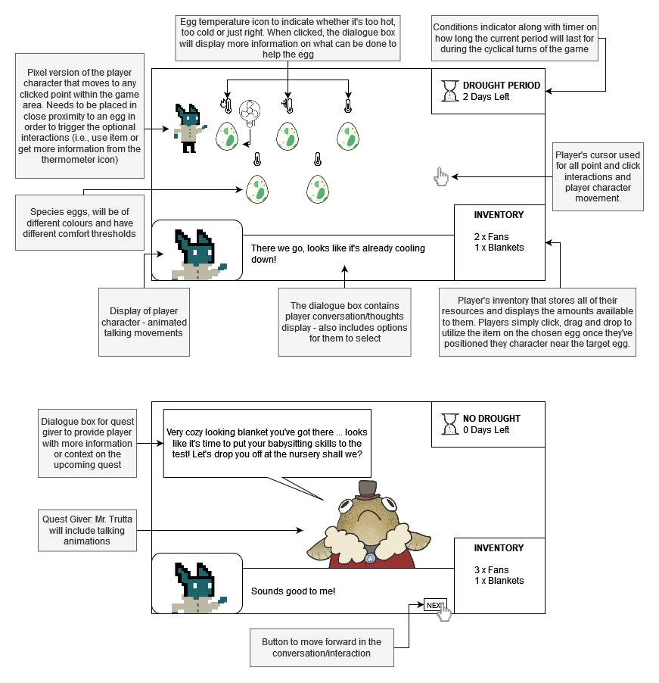

Figure - Interface breakdown of different screens based on the two distinct periods of the game

# Storyboard

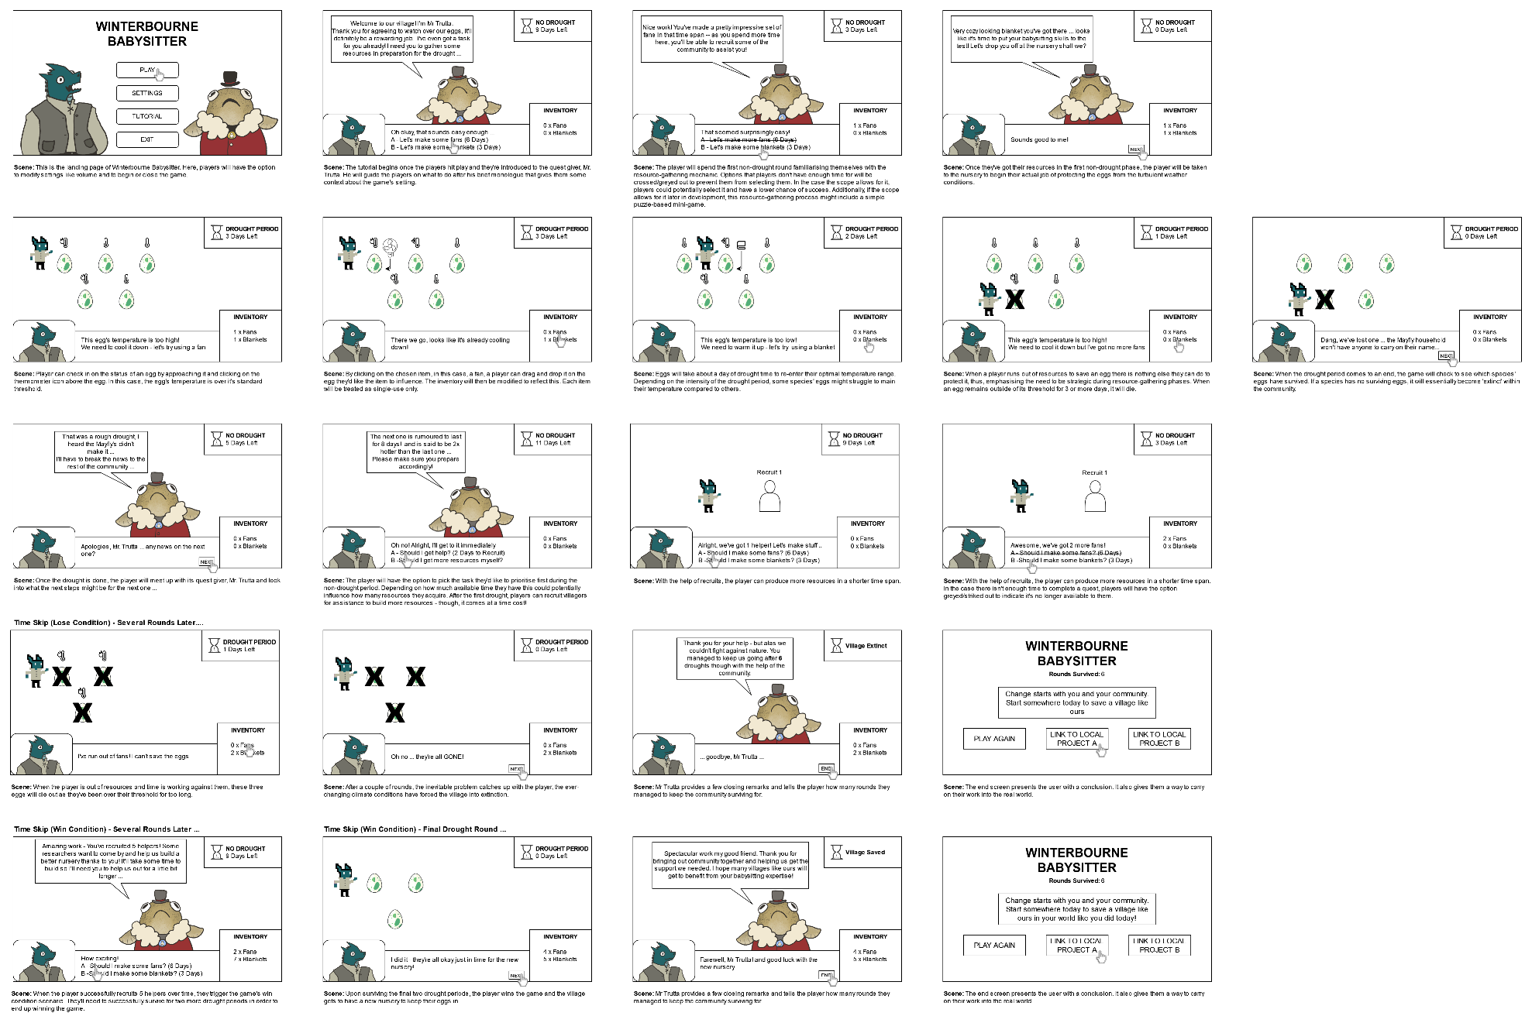

# References

Alyaz, Y., Spaniel-Weise, D., Gursoy, E., 2017. A Study on Using Serious Games in Teaching German as a Foreign Language. *Journal of Education and Learning*, 6(3), pp.250–264. 10.5539/jel.v6n3p250.

National Learning Network, *NLN Guidelines* [online]. Available at: http://ncam.wgbh.org/richmedia/showcase.html].

Web Content Accessibility Guidelines (WCAG), 2022. Web Content Accessibility Guidelines [online]. Available at: https://wcag.com/ [Accessed 12 December 2022].

Chittaro, L., Buttussi, F., 2015. Assessing Knowledge Retention of an Immersive Serious Game vs. a Traditional Education Method in Aviation Safety; Assessing Knowledge Retention of an Immersive Serious Game vs. a Traditional Education Method in Aviation Safety [online]. *IEEE Transactions on Visualization and Computer Graphics*, 21. Available at: http://www.ieee.org/publications_standards/publications/rights/index.html.

Dernbach, J.C., Cheever, F., 2015. Sustainable Development and Its Discontents [online]. *Transnational Environmental Law*, 4(2), pp.247–287. Available at: https://doi.org/10.1017/S2047102515000163.

Down, L., 2006. Addressing the challenges of mainstreaming education for sustainable development in higher education. *International Journal of Sustainability in Higher Education*, 7(4), pp.390–399. 10.1108/14676370610702190/FULL/PDF.

Game Accessibility Guidelines, 2022. Include interactive tutorials [online]. Available at: https://gameaccessibilityguidelines.com/include-tutorials/ [Accessed 12 December 2022].

Hampshire & Isle of Wight Wildlife Trust, 2021. All Change: The Climate and our Chalk Streams [online]. Available at: https://www.hiwwt.org.uk/blog/hiwwt/all-change-climate-and-our-chalk-streams [Accessed 10 December 2022].

Hannig, A. et al., 2012. EMedOffice: A web-based collaborative serious game for teaching optimal design of a medical practice [online]. *BMC Medical Education*, 12(1), pp.1–15. Available at: https://bmcmededuc.biomedcentral.com/articles/10.1186/1472-6920-12-104 [Accessed 27 November 2022].

Megasploot, 2022. Dungeondraft [online]. Available at: https://dungeondraft.net/ [Accessed 8 December 2022].

Nottingham Trent University, 2022. Green Academy Team [online]. Available at: https://www.ntu.ac.uk/about-us/strategy/sustainability/sustainability-in-curriculum/meet-the-team [Accessed 29 November 2022].

Papastergiou, M., 2009. Digital Game-Based Learning in high school Computer Science education: Impact on educational effectiveness and student motivation. *Computers & Education*, 52(1), pp.1–12. 10.1016/J.COMPEDU.2008.06.004.

Peña Miguel, N., Corral Lage, J., Mata Galindez, A., 2020. Assessment of the Development of Professional Skills in University Students: Sustainability and Serious Games [online]. *Sustainability*. Available at: www.mdpi.com/journal/sustainability.

Quality Assurance Agency for Higher Education, Advance HE, 2021. *Education for Sustainable Development Guidance*.

Rossano, V., Roselli, T., Calvano, G., 2017. A serious game to promote environmental attitude [online]. *Smart Innovation, Systems and Technologies*, 75, pp.48–55. Available at: https://link.springer.com/chapter/10.1007/978-3-319-59451-4_5 [Accessed 27 November 2022].

Sandbrook, C., Adams, W.M., Monteferri, B., 2014. Digital Games and Biodiversity Conservation [online]. Available at: https://conbio.onlinelibrary.wiley.com/doi/10.1111/conl.12113.

Serious Brothers, 2022. Imagine Earth - Planetary Colonization [online]. Available at: https://www.imagineearth.info/ [Accessed 27 November 2022].

SeriousGeoGames Lab, 2022. Crabby’s Reef – Gaming for the Earth [online]. Available at: https://seriousgeogames.wpcomstaging.com/activities/crabbysreef/ [Accessed 27 November 2022].

Stubbington, R. et al., 2017. Temporary streams in temperate zones: recognizing, monitoring and restoring transitional aquatic-terrestrial ecosystems [online]. *WIREs Water*, 4, p.1223. Available at: https://wires.onlinelibrary.wiley.com/doi/10.1002/wat2.1223.

Tabletop Audio, 2022. Ambiences and Music for Tabletop Role Playing Games [online]. Available at: https://tabletopaudio.com/ [Accessed 28 November 2022].

The Conversation, 2022. Chalk streams: why ‘England’s rainforests’ are so rare and precious [online]. Available at: https://theconversation.com/chalk-streams-why-englands-rainforests-are-so-rare-and-precious-172827 [Accessed 10 December 2022].

Tsopra, R. et al., 2020. AntibioGame®: A serious game for teaching medical students about antibiotic use. *International Journal of Medical Informatics*, 136. 10.1016/J.IJMEDINF.2020.104074.

Ullah, M. et al., 2022. Serious Games in Science Education. A Systematic Literature Review. *Virtual Reality and Intelligent Hardware*, 4(3), pp.189–209. 10.1016/J.VRIH.2022.02.001.

United Nations Department of Economic and Social Affairs, 2022. THE 17 GOALS | Sustainable Development [online]. Available at: https://sdgs.un.org/goals [Accessed 29 November 2022].